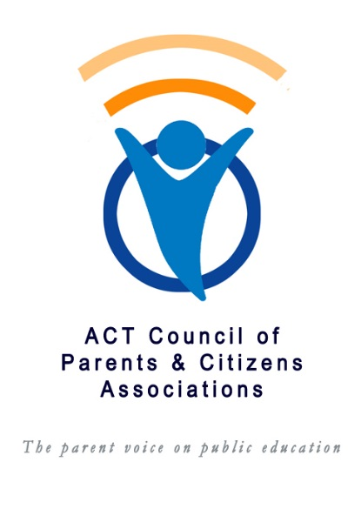
Violence in Schools – Case Study
The below information will be included in a compilation of case studies to assist the P&C Council in its advice to the Education Directorate and ACT government about reducing violence in schools, providing an acceptable complaints procedure and proactive measures to assist students and parents.
Please answer the below questions to the best of your knowledge and attach additional pages if you wish. Personal identification details are not required on this form.
Return the form to contact@actparents.org.au
What happened and when?

What impact has this violence had on your child?

How was the incident reported to the school and by whom? Did you meet with the school staff or principal?

How was the incident recorded by the school and investigated?

What advice were you given by the school?

Are you aware of the school implementing any changes to reduce the risk of similar incidents and did those changes work?

Did your child receive the support they needed?

Were the Education Directorate policies and guidelines for addressing such matters explained to you? If so do you think they followed those policies/guidelines?

Did you seek to elevate the matter to higher levels and what was the result of any appeal process?

Was there any adverse treatment of your child or family by the school or Directorate?

Do you believe that the school and Directorate demonstrated their duty of care to you child?

Is your child still at the school and if not what are the main reasons for leaving it?

What changes if any would you like to see happen at the school and Directorate level?

Are you aware of any activities, procedures or initiatives in any schools to avoid violence by students and if so were they successful in your opinion?

Any other comments, please:

What support services did you find useful and how did you find them?

