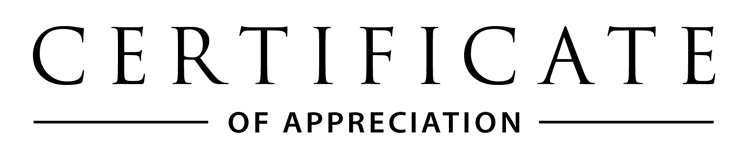

**Veronica Elliott**  
Executive Officer  
ACT Council of P&C Associations

**Katy Haire**  
Director-General  
ACT Education Directorate

INSERT NAME HERE

***You make our school a better place.***

The ACT Council of P&C Associations and ACT Education Directorate   
would like to express our sincere **GRATITUDE** and **THANKS** to