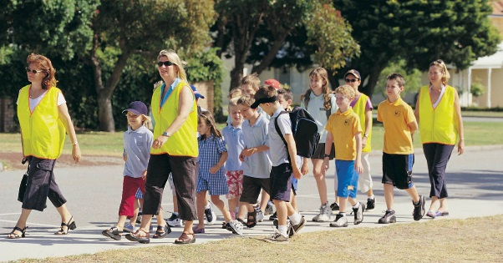

Who are we?
The <your school> Parents and Citizens (P&C) Association is the focal point for parent involvement at the school and provides a place for parents to discuss and debate matters of interest relating to the school and community.

All parents or guardians of children at <your school> are automatically members of the P&C.

The P&C holds regular meetings throughout the school year. All parents and carers are welcome to attend, hear about what is happening around the school, propose ideas and participate.

Each <insert month>, an Annual General Meeting is held and an executive committee is appointed. Nominations and votes come from members who attend that meeting.

The executive committee oversees the Association’s operation while co-ordinators or sub-committees look after each of the services which the P&C provides.

What do we do?
The P&C provides strong community support for the school by encouraging parents to be involved in the workings of the school.

We run many events and provide a number of services for students and families. These include:
- School Canteen with a focus on healthy food choices (open Wednesday-Friday)
- A uniform shop at the school (<add opening hours if you want>)
- A second-hand uniform pool
- Breakfast Club, providing a free, nutritious breakfast to students
- A Walking School Bus providing a social and supervised walk to school
- Events such as discos, movie nights and trivia nights
- The annual school Fair
- Mother’s Day and Father’s Day stalls
- Scholastic Book Club
- School Banking
- Fundraising to provide improvements to the school and new resources for students
- Input into ACT school policies via the ACT Council of P&C Associations
<Choose/add items to reflect what your P&C does>

Helping out
The P&C values the rich diversity of skills and experiences that each family brings to the school. We appreciate any help that families are able to offer.

Ways you can help include:
- Help for a few hours in the canteen
- Assist at school sporting events
- Sort lost property or the second-hand clothing pool
- Attend P&C meetings or participate on P&C sub-committees
- Bake for fundraising events
- Be a Walking School Bus ‘driver’
- Run a stall at the Fair
- Cook at community BBQs
- Respond to specific requests for help from your child’s teacher.
- Become a Council delegate
<amend list to reflect your school needs/opportunities>
To find a job that suits, you might like to come along to a P&C meeting or join our email distribution list.

Contacts

To find out more about your P&C,
visit the P&C section of the School’s web site:
<web address>

Or, email <address>

Or, contact a school P&C representative:

<name> (<position>): <phone or email>

The P&C also has an email distribution list which we use to send information and occasional calls for help. To join the list, send a request to the P&C email <address>.

<delete sections above, depending on your operations and preference.>

More information about what P&Cs do can also be found from the ACT Council of P&C Associations (the peak body of P&Cs in the ACT). Call 6241 5759 or see www.actparents.org.au.

<your school address>

Phone: <insert>
Fax: <insert>
Email: <insert>

<insert school or P&C logo>

Our P&C Association
<Insert a picture of parents helping or one of your services here.>
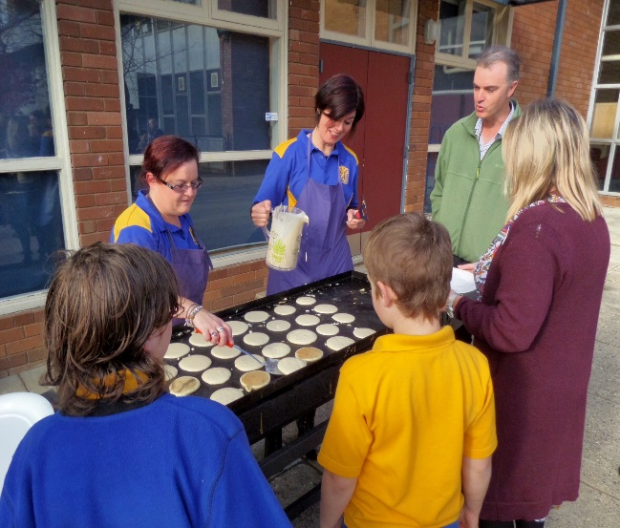

Benefits of participating
P&C activities create opportunities for parents and carers, students and staff to interact, building a feeling of respect and a stronger, safer, school community.

When you participate, you benefit by:
- meeting other parents in the community
- understanding more about what happens at school
- getting to know the teachers better
- sharing your skills with other parents/teachers and learning new ones
- helping out sets a good example for your children

Your children will benefit too. Research shows that when parents are involved, students get better grades, have a better attitude to school and improved behaviour!

