A P&C contact for early learning families (Preschool/Kindy)
A preschool-kindy parent representative on the P&C committee is an invitation to families with young children to participate. The role supports family involvement and engagement at school in the early years. It’s an acknowledgement of the importance of families to early years learning.

But why?
Parents and carers with children in the early years of schooling appreciate a welcoming community – particularly if it’s the first child, or a relocated family. Parents tell us they want to make connections, find information, and ensure their children are happy. They may be anxious or overwhelmed, all while navigating new routines and unfamiliar terminology.
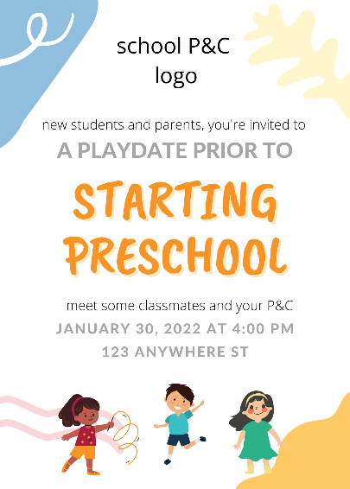
Caregivers appreciate a little extra support and orientation is a good time for P&Cs to reach out, extend a welcome, and be visible and accessible to new parents, carers, and families.

Relationships
Starting school is all about relationships for children and their families. Children enjoy activities with their community and opportunities for parents, families, and school staff to engage in activities together are beneficial for building trust in early years communities. A trusted network helps build a sense of belonging – a core component of the early years learning framework.

Key events for new families
- Enrolling in preschool or kindergarten,
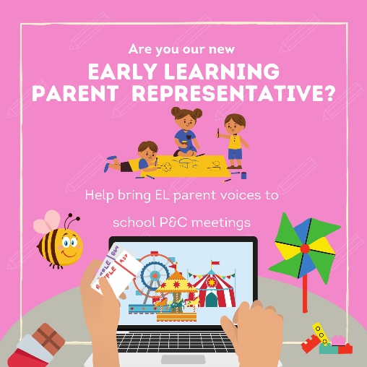
- receiving/confirming an offer,
- finding out about the school,
- planning and supporting children getting ready for school,
- starting school,
- Participating, engaging, and getting to know about school.
The following page can be customised to describe your P&Cs early learning focus and objectives.

Role Description: P&C Parent Representative (Volunteer)
Preschool/Kindy/Early Learning
NB ensure the role doesn’t overwhelm the incumbent and meets the capacity of individual volunteer/s
What the preschool parent rep might do
P&C’s determine their priorities according to the constitution and community priorities of the association.
[school name] P&C Association aims to support our early years school community through activities focussed on [welcoming new parents and building community engagement].
The role could focus on 1-3 of the following:
- Introduce the role (see letter template)
  - To key school staff ie principal, deputy principal, reception, business manager
  - To P&C members, school parents and carers.
- Establish your key collaborators ie P&C committee and parents, principal, EL executive teacher, librarian (interact or report/request feedback regularly),
- Review communication protocols and parent participation numbers,
- Identify opportunities to connect with the early years parent and carer community,
- Open a free Canva account to access Council’s customisable templates (see below),
- Review and updat information, event calendars, and invitations, for early years families
- Record existing opportunities to engage with parents and carers, and ways to collect/share outcomes and feedback,
- Establish or update a parent representative manual or guide for the role ie key dates, plans, activities, contacts,
- Attend and/or report to P&C early learning committee mtgs.
Resources
- Council provides free training for P&Cs. Please register via the training link.
- for early learning parent representatives and for parents are available under early learning on Council’s website weblink
- Reference guide for early years parents
- Quarterly early learning meetings for parent reps

Contact
Marina Spurgin, Early Learning Officer,
ACT Council of P&C Association

